PUBPOL 4390/5390 “Day 14 in-class exercise”
Group Names (all members): _________Thelonious____________________________________

We will use the datasets “Gsmall” for training, and “H” for testing. Each one is a unique set of births from 2015.
- Using Dataset Gsmall, choose an OLS model with many (100+) covariates to predict birthweight. This could be the example set of covariates in “day13demo.do”, or others of your choice. The goal is to get a model that is “overfit” for OLS in-sample. That way the regularization models (LASSO, Ridge, EN) can show their worth). Fill in the SD and “OLS” columns in the table below.
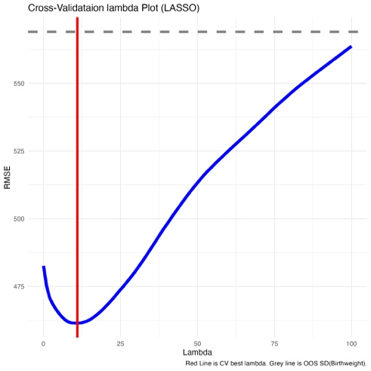
- Now use the same set of features, but estimate the model using LASSO. Use whatever defaults choices your program uses. Get predictions, and fill in the “LASSO” columns in the table above.

  - Create a “CV plot” to check out how the Cross-validation measure of goodness of fit varies with Lambda.

- Now estimate a model using the same set of features and Elastic Net. Let the model choose both “alpha” and “lambda”. Fill in the in-sample GOF, CV-GOF, and the actual out-of-sample (H) GOF. (this is the last row of the table)

- Now estimate the model using Rigde regression. Add the relevant info to the table.

- Finally, do a model with Elastic net, forcing alpha = 0.5, and letting cross-validation choose the Lambda. Add the relevant info to the table.

Interpretation/discussion questions:
- Are you able to get the models to run? To get predictions and assess GOF? Any barriers in implementation?
There were no barriers to implementation.
- How does the CV estimates of GOF do, compared to actual OOS?
  - We should think about this compared to “baseline” of SD(birthweight) in each sample.
Overall, the CV GOF estimates are pretty similar to the OOS GOF estimates. The largest discrepancy is OLS, but generally the cross-validation GOF is +/- 10 units from the OOS GOF
- How do the 4 models do compared to each other, out of sample: OLS, LASSO, Ridge, EN(alpha = 0.5) ?
Overall, the Elastic net with a CV-estimated mixture performs the best with the lowest OOS RMSE, but it is pretty similar to the LASSO with CV-estimated lambda. The OLS and Elastic net are the most overfit within sample, but across models the cross-validation estimates do a good job at approximating the OOS RMSE

GOF when training on “Dataset Gsmall”
 | Alpha | Lambda | RMSE
“Testing” Dataset |  |  | Gsmall (in-sample) | Gsmall (Cross-validation estimate) | H (out of sample)
SD(birthweight) | N/A | N/A | 608.83 | N/A | 569.05
OLS RMSE | N/A | 0 | 391 | 492 | 483
LASSO (auto-CV choice of bandwidth) | 1 | 11 | 405 | 461 | 459
Ridge (auto-CV choice of bandwidth) | 0 | 100 | 397 | 468 | 466
Elastic Net (set alpha = 0.5, let CV choose Lambda) | 0.5 | 14 | 399 | 462 | 462
Elastic Net (let CV choose alpha and Lambda) | .75 | 14 | 397 | 468 | 458

We will discuss together in class. Each group member should also upload a copy of their work to the class Canvas page under assignments. It’s OK for the group assignments to be identical among group members. Please make sure all group member names are on each person’s assignment.

